# **How to deploy Retail-app-Kubernetes on k8s cluster using Jenkins**

App repo : <https://github.com/Msocial123/Retail-App_kubernetes.git> -b master

**Eks cluster**

* Firstly, we need to set up k8s cluster in aws
* Create a linux server with ubuntu os, instance type is t2.medium and storage is 30gb for setting up eks cluster

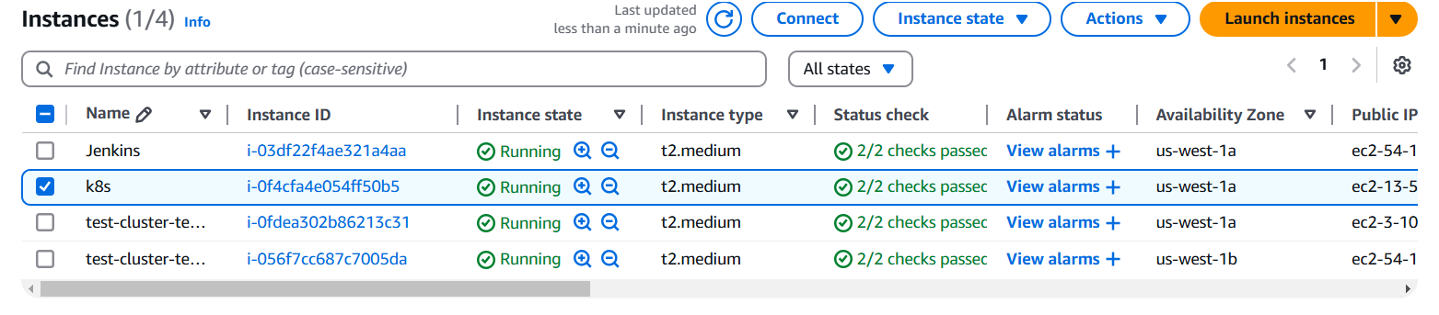

* Connect your ec2 instance with putty using shh client
* After that you have to install following cli tools on your server 👇

1. **Eksctl**

**Description: -** eksctl is a simple CLI tool for creating and managing clusters on EKS - Amazon's managed Kubernetes service for EC2. It is written in Go, uses CloudFormation

**Command:**  # for ARM systems, set ARCH to: `arm64`, `armv6` or `armv7`

ARCH=amd64

PLATFORM=$(uname -s)_$ARCH

curl -sLO "https://github.com/eksctl-io/eksctl/releases/latest/download/eksctl_$PLATFORM.tar.gz"

# (Optional) Verify checksum

curl -sL "https://github.com/eksctl-io/eksctl/releases/latest/download/eksctl_checksums.txt" | grep $PLATFORM | sha256sum --check

tar -xzf eksctl_$PLATFORM.tar.gz -C /tmp && rm eksctl_$PLATFORM.tar.gz

sudo mv /tmp/eksctl /usr/local/bin

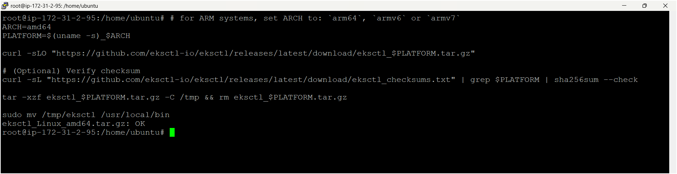

1. **Kubectl**

**Description: -** kubectl is the command-line tool for interacting with Kubernetes clusters. It allows users to manage Kubernetes resources and perform various tasks such as deploying applications, inspecting and modifying cluster resources, and troubleshooting cluster issues.

**Command: -**

* Install kubectl binary with curl on Linux

curl -LO [https://dl.k8s.io/release/**$(**curl -L -s https://dl.k8s.io/release/stable.txt**)**/bin/linux/amd64/kubectl](https://dl.k8s.io/release/$(curl%20-L%20-s%20https://dl.k8s.io/release/stable.txt)/bin/linux/amd64/kubectl)

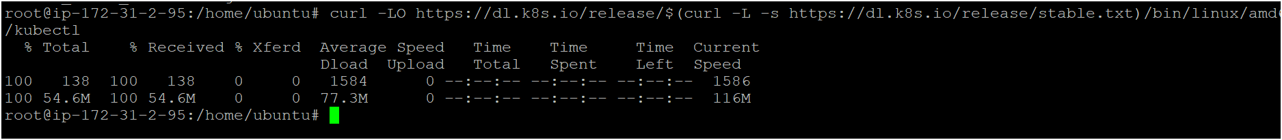

* Validate the binary (optional)

Download the kubectl checksum file:

curl -LO "https://dl.k8s.io/release/**$(**curl -L -s https://dl.k8s.io/release/stable.txt**)**/bin/linux/amd64/kubectl.sha256"

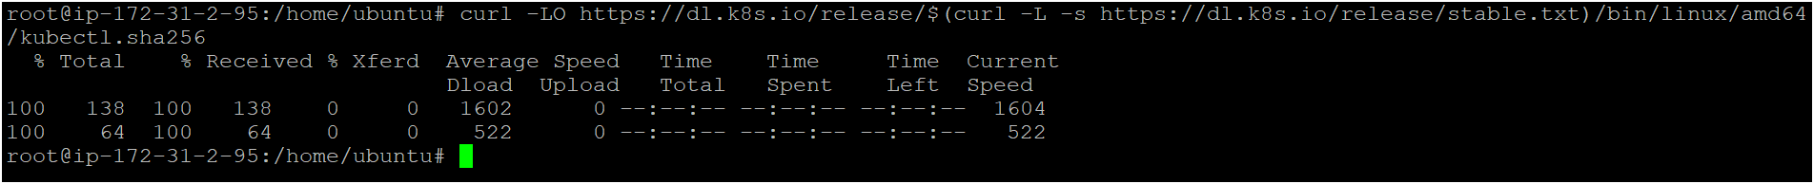

* Validate the kubectl binary against the checksum file:

echo "**$(**cat kubectl.sha256**)** kubectl" | sha256sum –check



* Install kubectl

sudo install -o root -g root -m 0755 kubectl /usr/local/bin/kubectl

chmod +x kubectl

mkdir -p ~/.local/bin

mv ./kubectl ~/.local/bin/kubectl

* Test to ensure the version you installed is up-to-date:

kubectl version –client

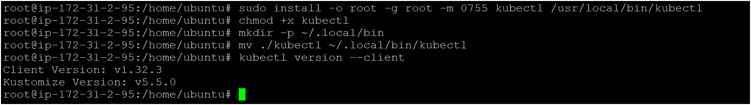

1. **AWS CLI**

**Description: -** The **AWS Command Line Interface (CLI)** is a tool provided by Amazon Web Services that enables users to interact with AWS services from a terminal or command prompt. It allows you to perform various AWS tasks directly from the command line, including managing resources, configuring settings, and automating workflows.

**Command: -**

apt install unzip -y

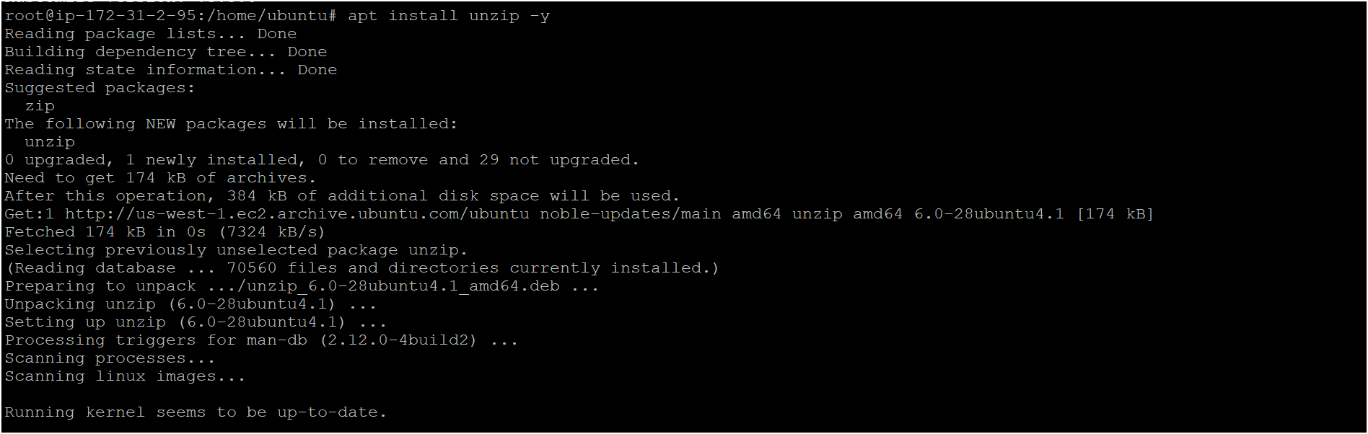

curl "https://awscli.amazonaws.com/awscli-exe-linux-x86_64.zip" -o "awscliv2.zip"



unzip awscliv2.zip

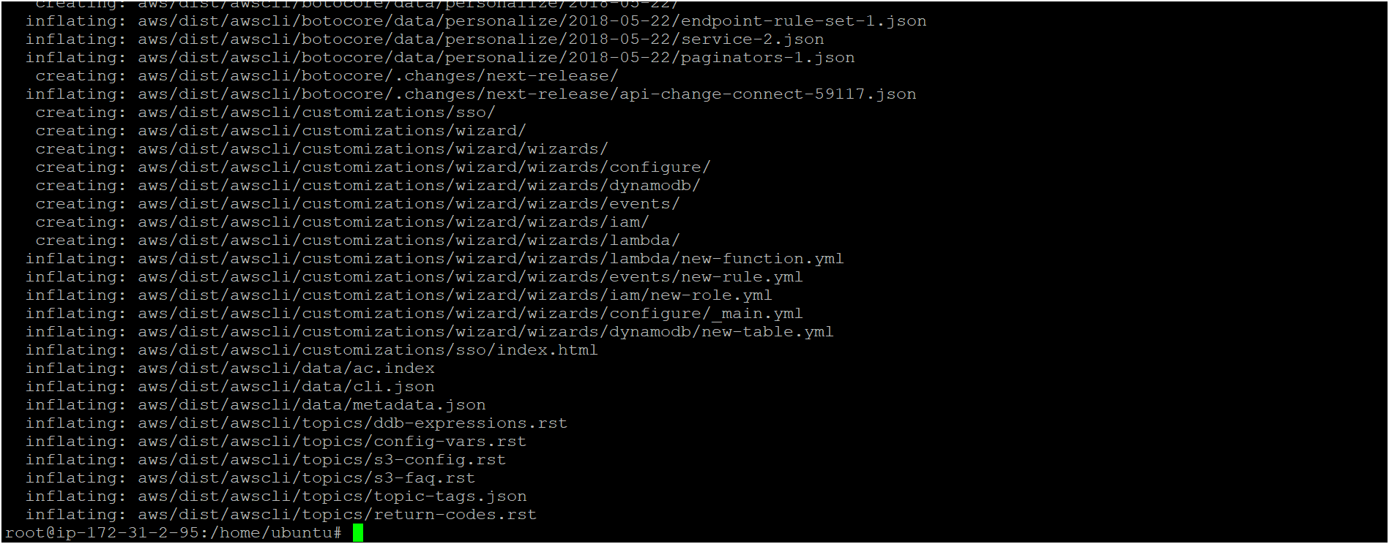

sudo ./aws/install



**Confirm the installation with the following command: -**

**aws --version**



**IAM USER: -**

* Create one iam user as following below steps 👇
* Click on IAM service or search for IAM in aws console

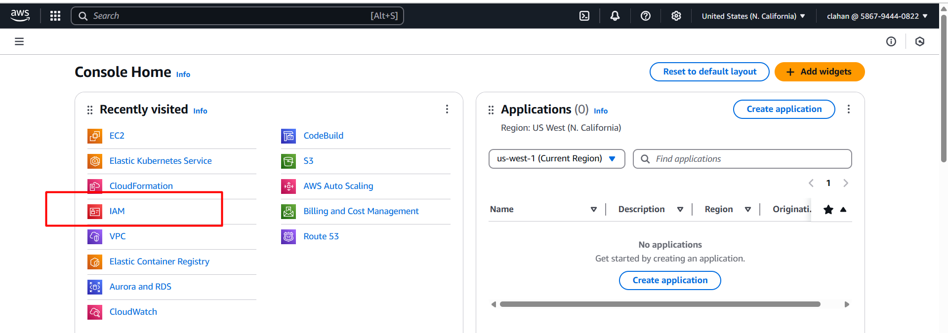

* Click on users 🡪 create user

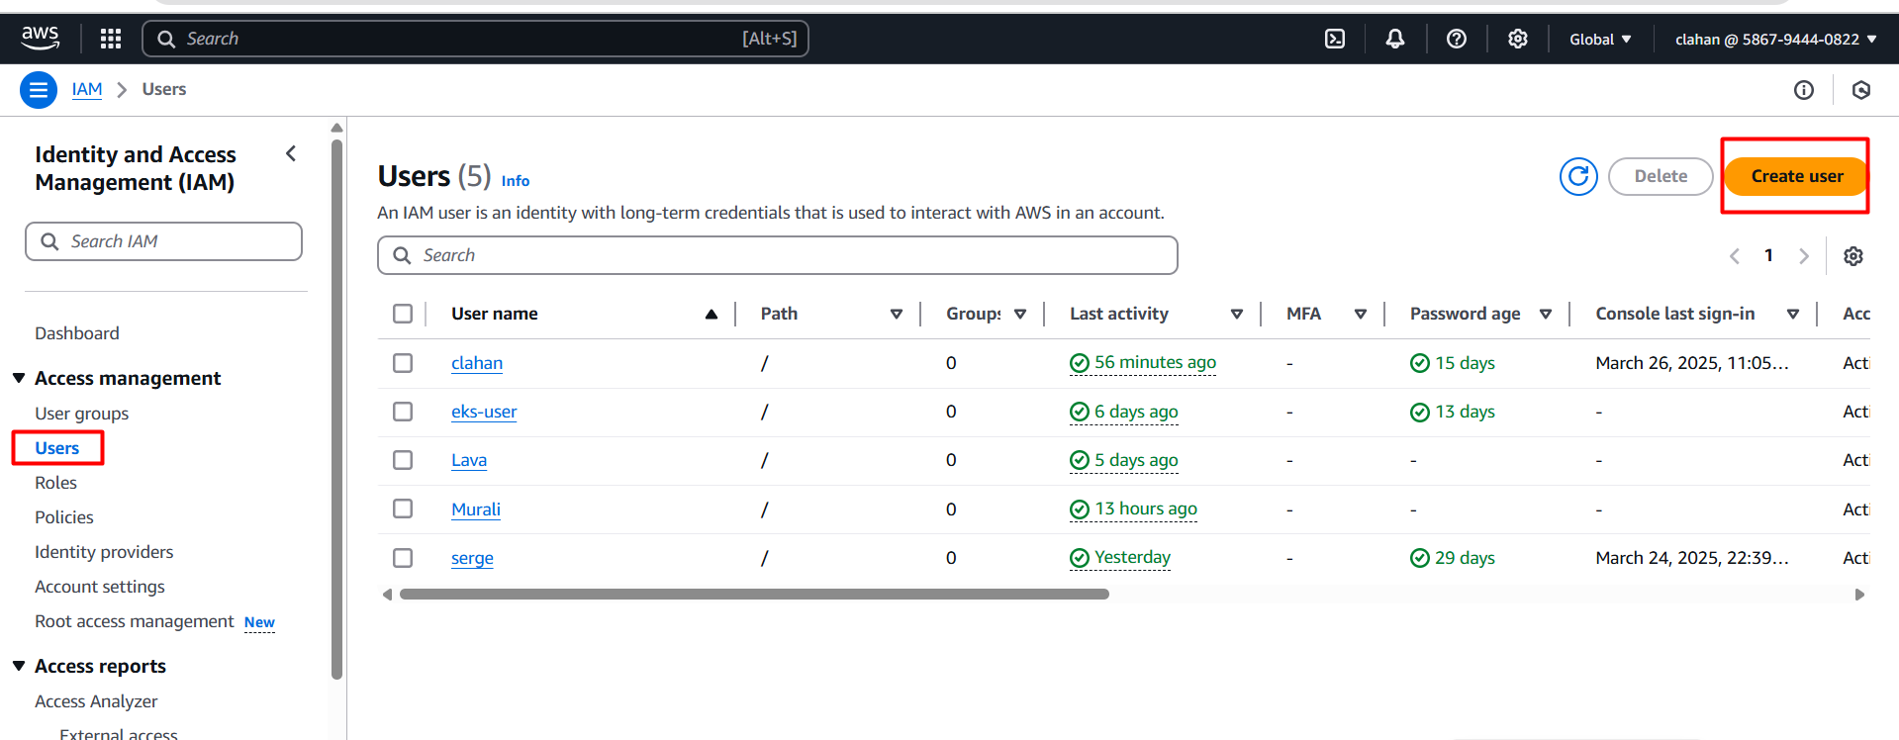

* Give a name and click on next

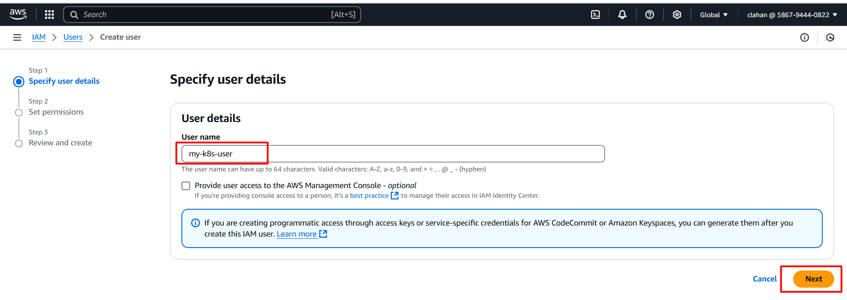

* Choose attach policies directly and select permission “Administrator access” and click on next

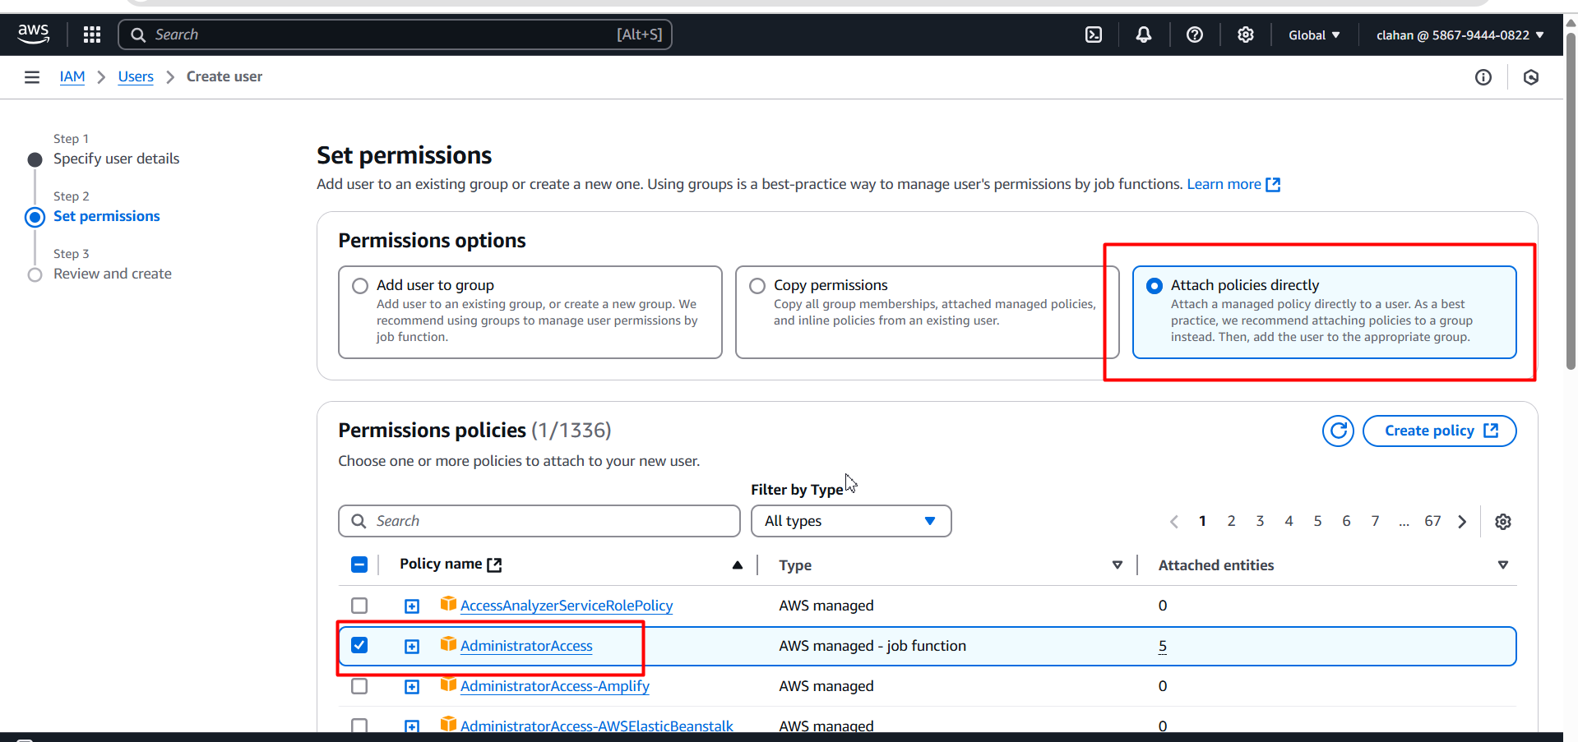

* Review the details then click on create user

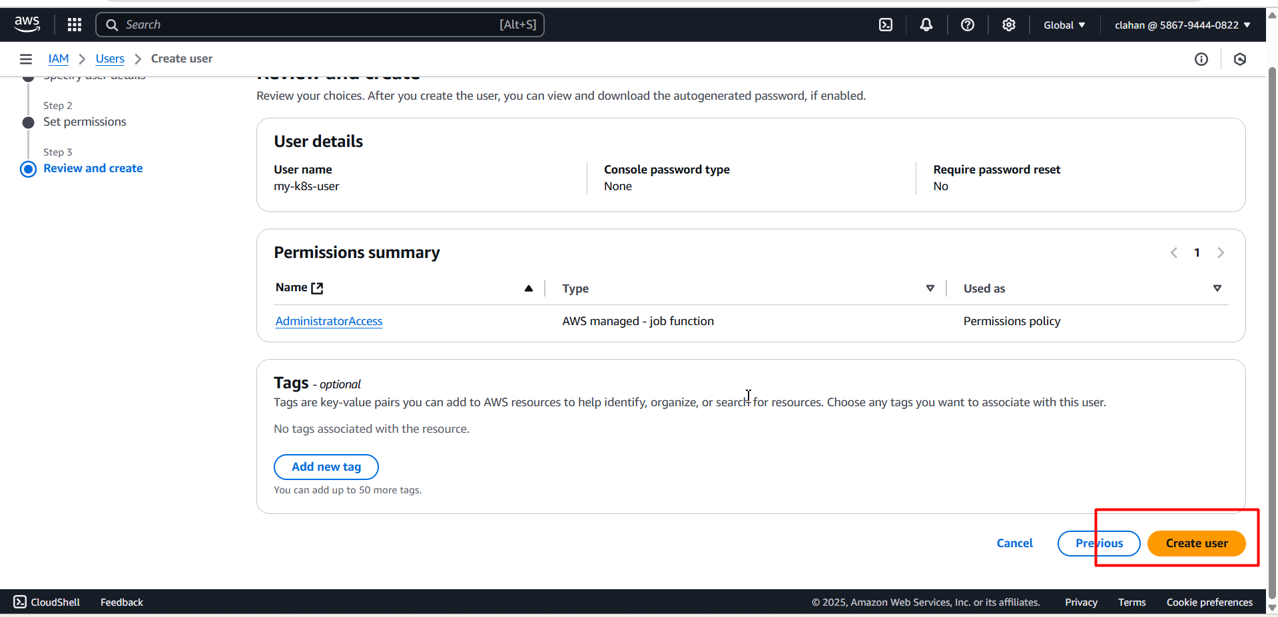

* IAM user created and click on view

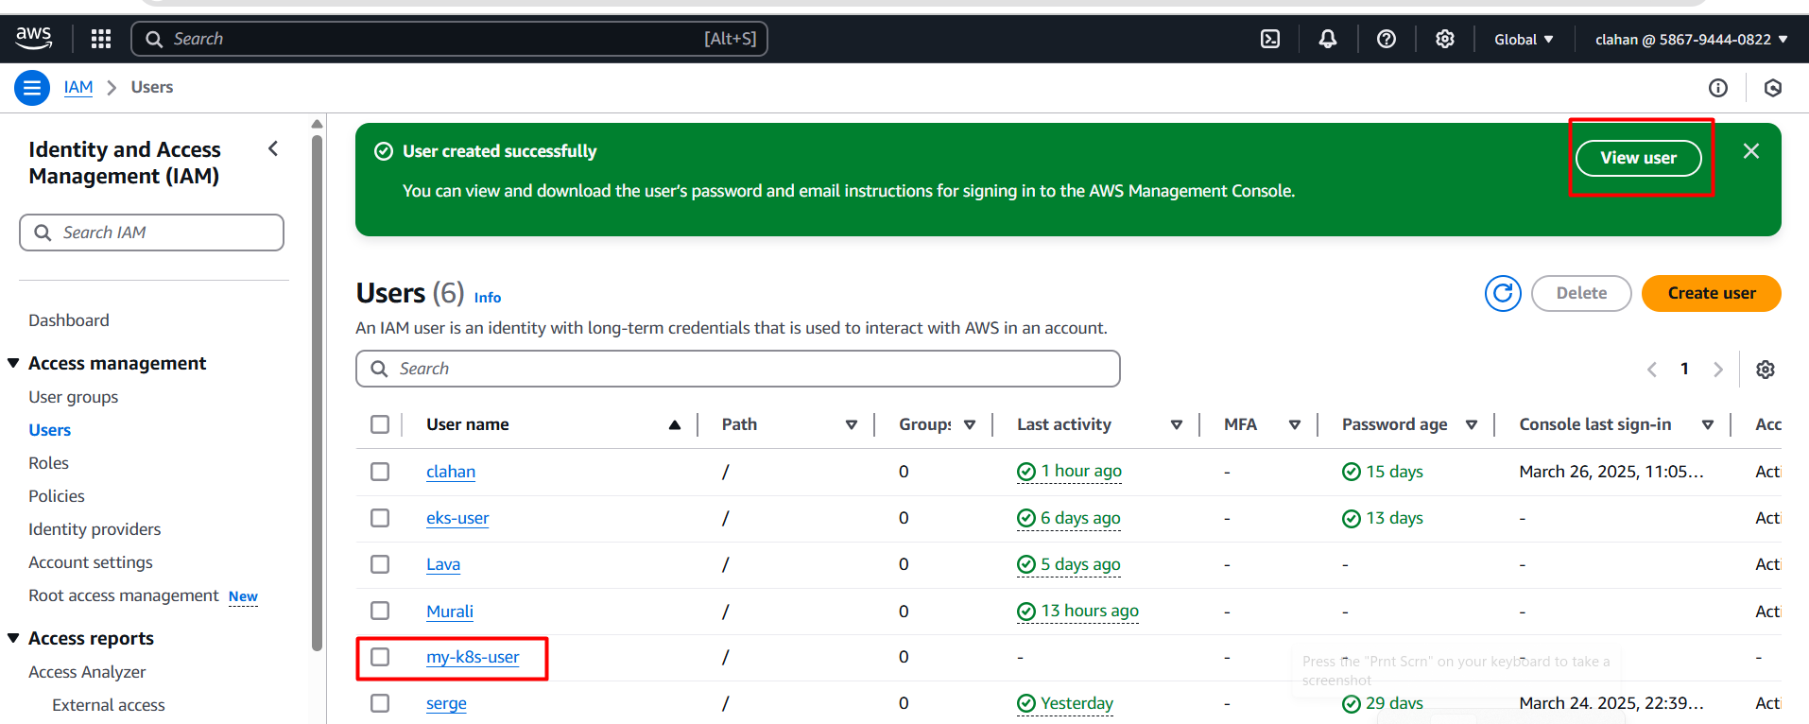

* Inside the iam user click on security credentials 🡪 click create access key (we need generate access key id & secret access key id for providing in cluster)

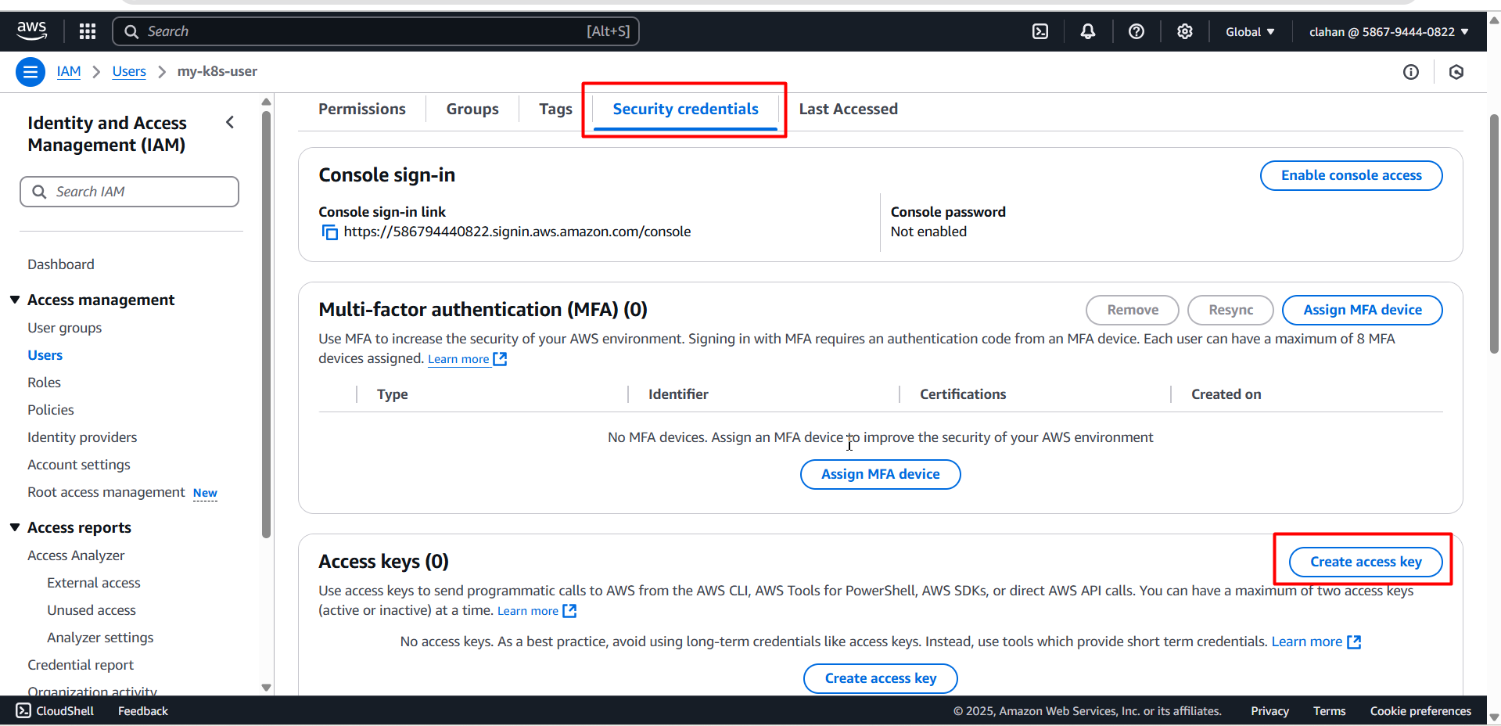

* Next choose command line interface (cli) 🡪 confirm the check box (below) 🡪 click on next

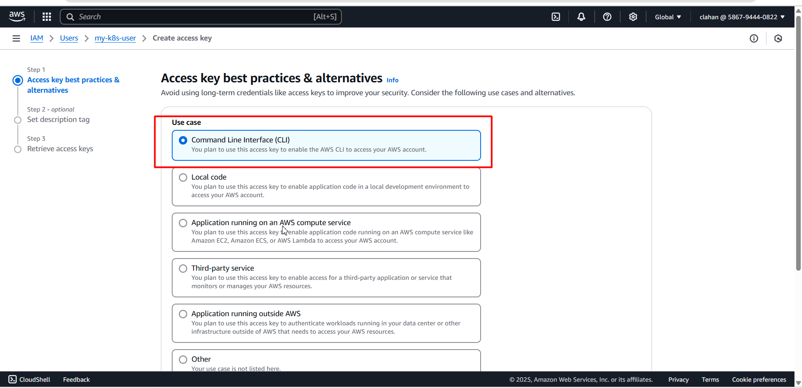

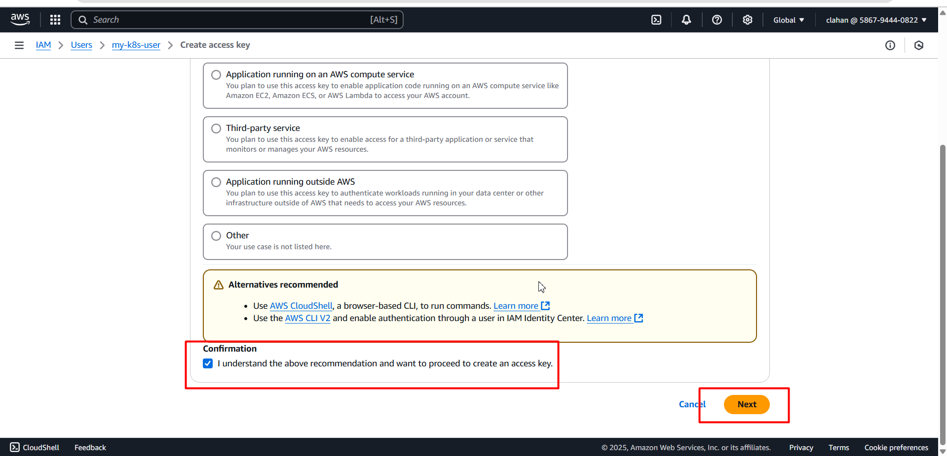

* Click on create access key

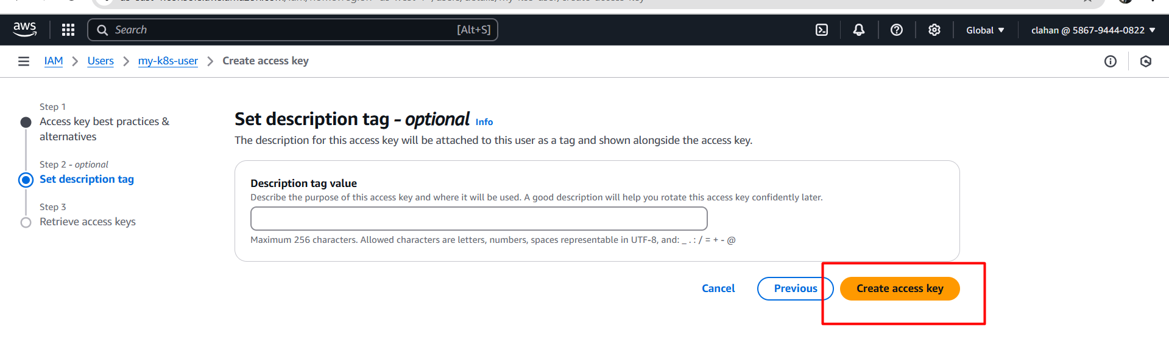

* Access keys are only visible one time so download them locally by clicking on download.csv file

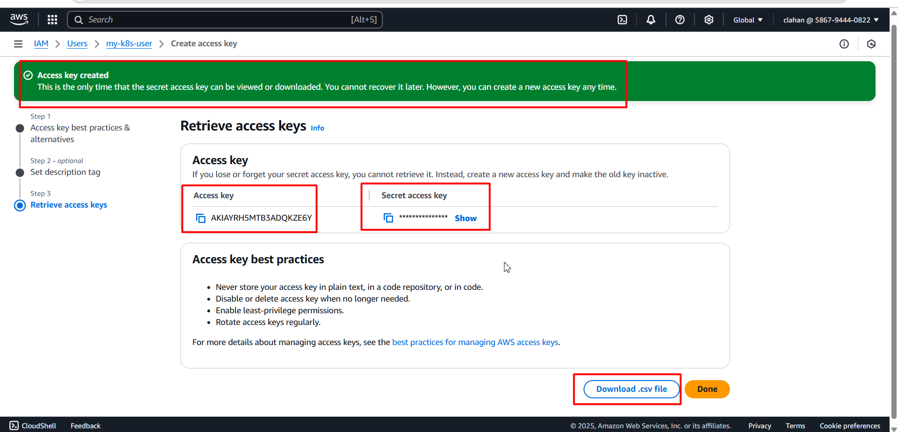

* Click on Download.csv file it will download into your file manager

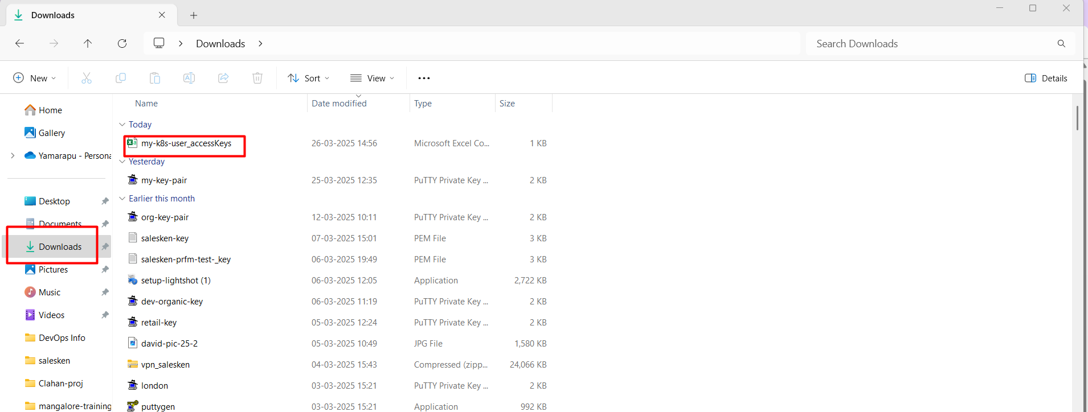

* Now you have to provide/configure those access keys and secret key id on your server

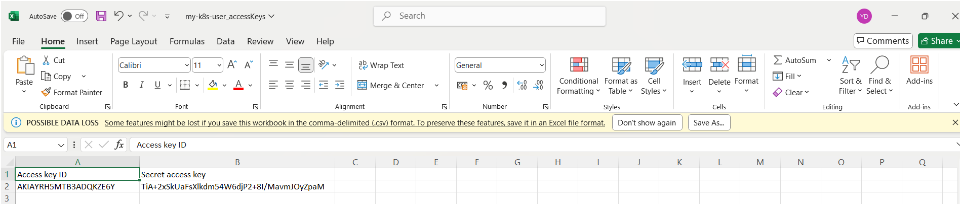

aws configure (execute this command on your terminal)

* Specify your using region

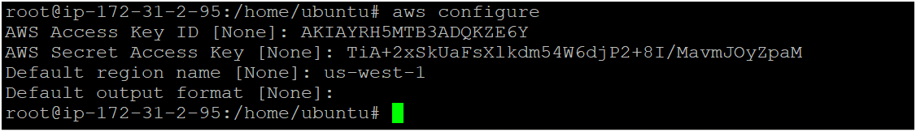

* Now you can create eks cluster by executing following command

eksctl create cluster --name <cluster_name> --region <your_region> --zones <availability_zones> --nodegroup-name <nodegroip_name> --node-type <instance_type> --nodes <no.of.nodes>

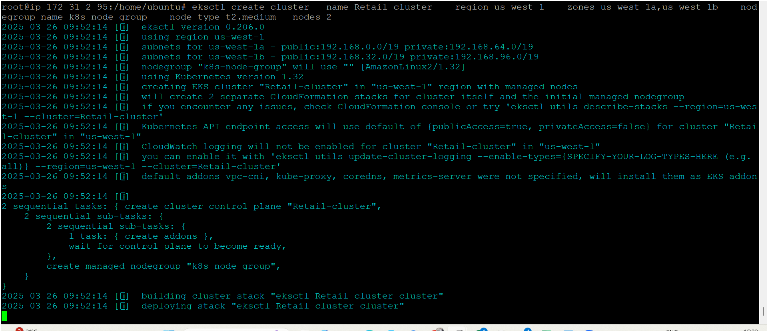

* Now your cluster is ready as shown below image 👇

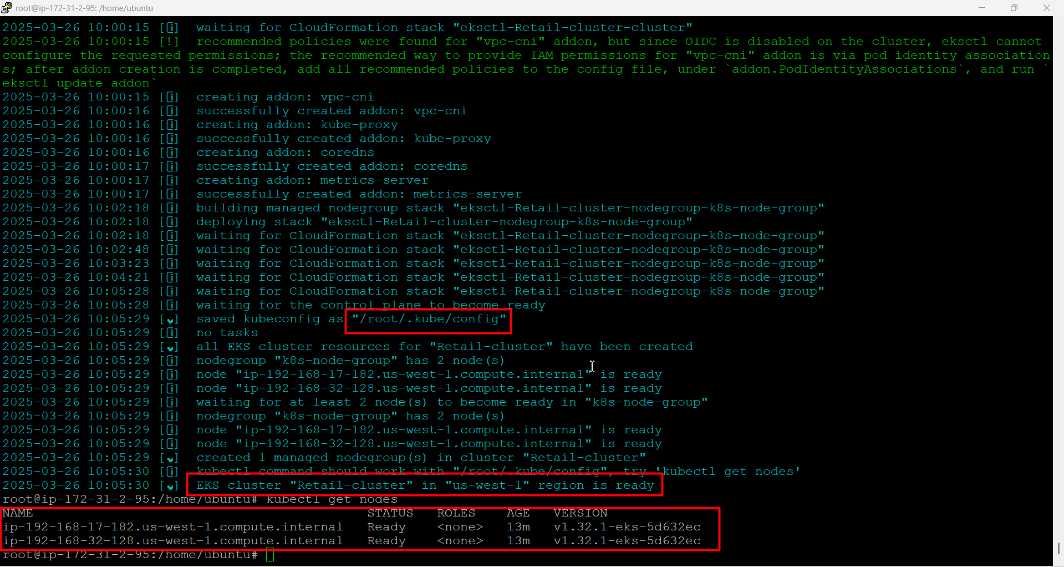

# **Argocd in K8s**

# Install argocd in eks cluster

* Install argocd namespace

kubectl create namespace argocd

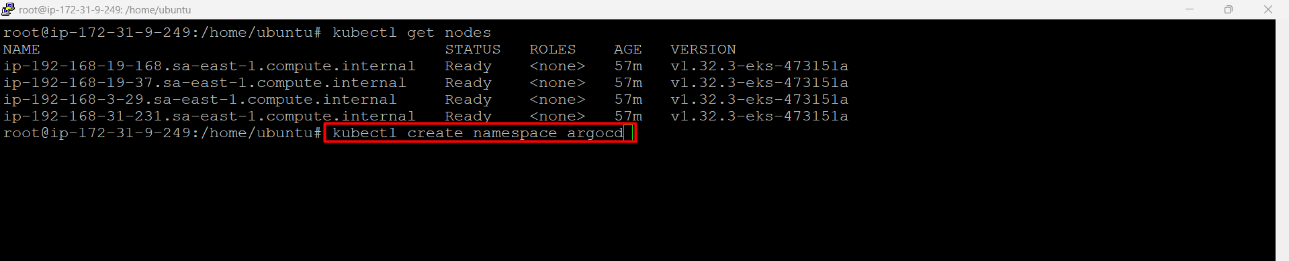

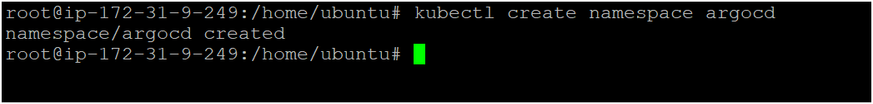

* Install argocd

kubectl apply -n argocd -f https://raw.githubusercontent.com/argoproj/argo-cd/stable/manifests/install.yaml

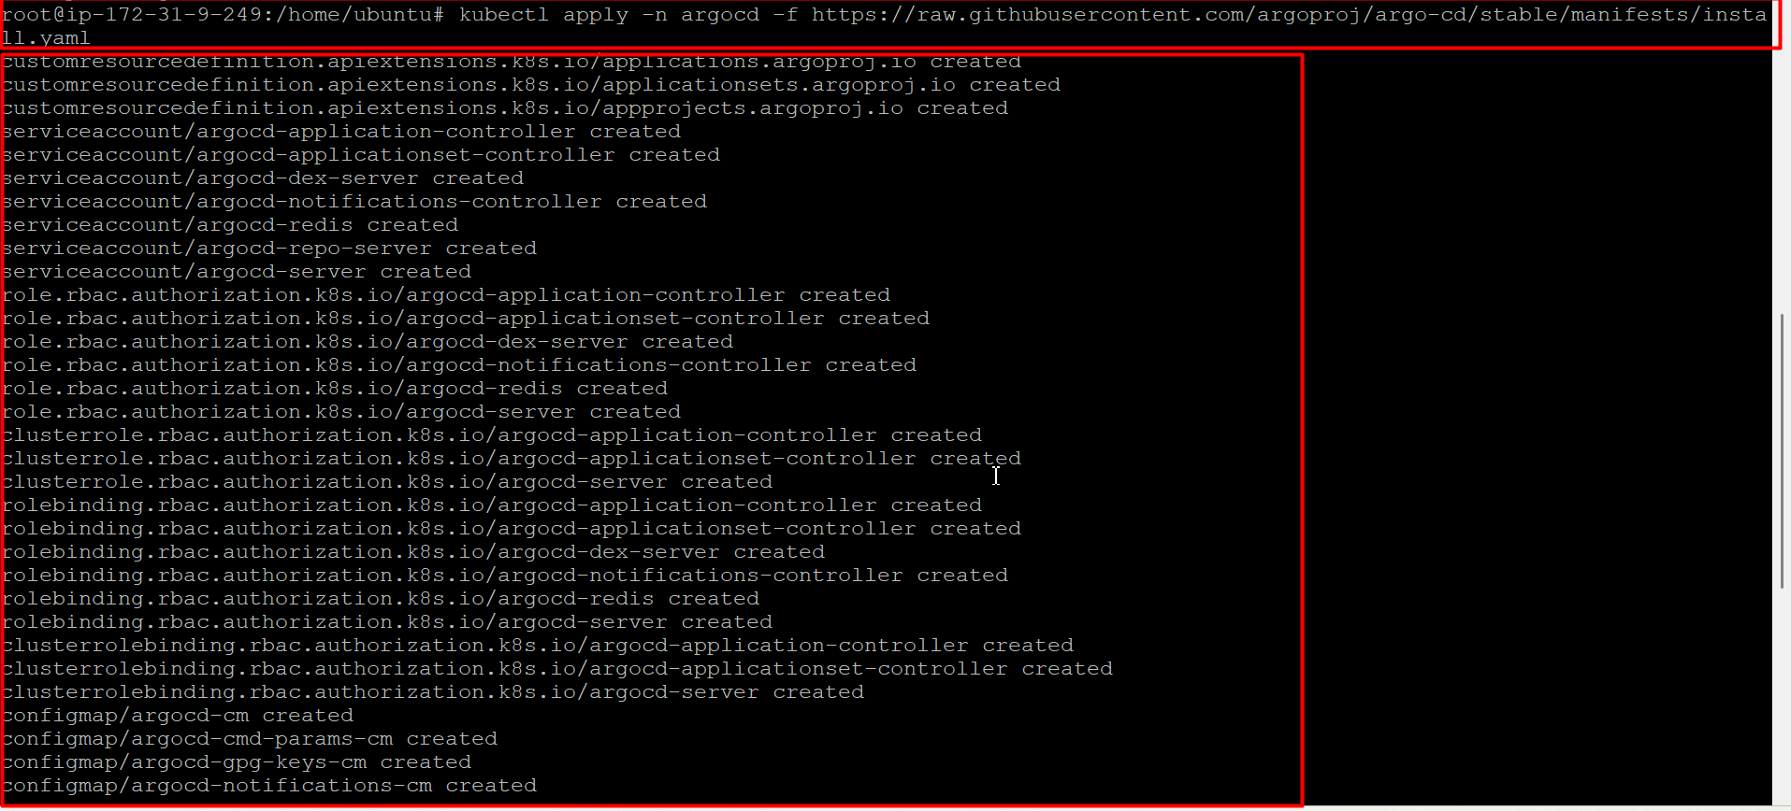

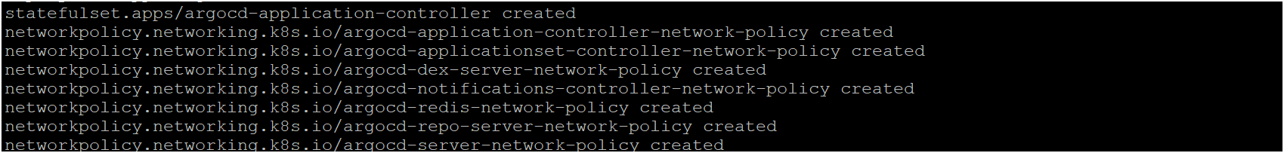

Download Argo CD CLI

curl -sSL -o argocd-linux-amd64 https://github.com/argoproj/argo-cd/releases/latest/download/argocd-linux-amd64

sudo install -m 555 argocd-linux-amd64 /usr/local/bin/argocd

rm argocd-linux-amd64



Access The Argo CD API Server

By default, the Argo CD API server is not exposed with an external IP. To access the API server, choose one of the following techniques to expose the Argo CD API server:

Service Type Load Balancer[¶](https://argo-cd.readthedocs.io/en/stable/getting_started/#service-type-load-balancer)

Change the argocd-server service type to LoadBalancer:

kubectl patch svc argocd-server -n argocd -p '{"spec": {"type": "LoadBalancer"}}'



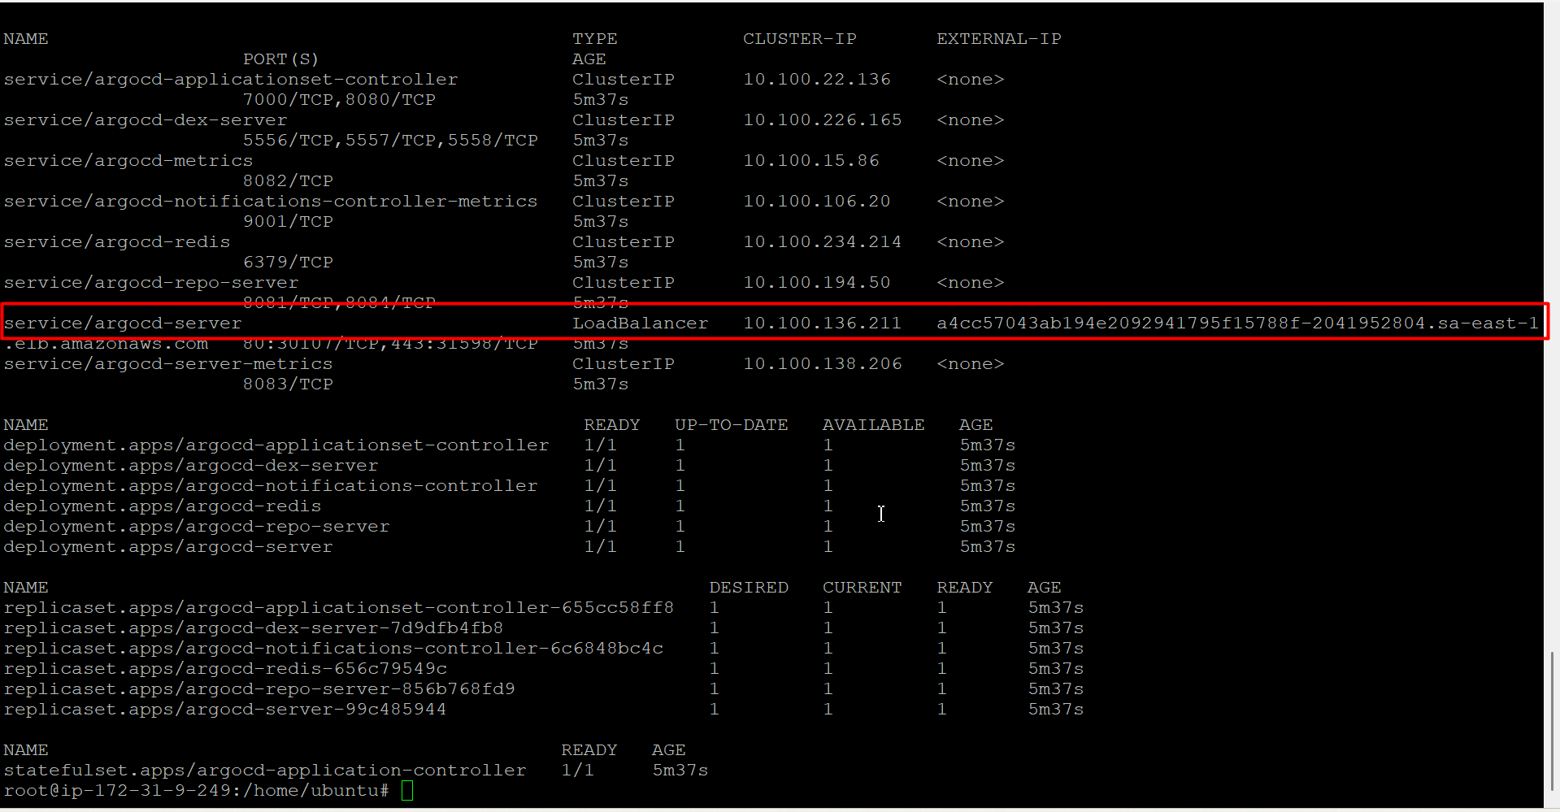

Port Forwarding

Kubectl port-forwarding can also be used to connect to the API server without exposing the service.

kubectl port-forward svc/argocd-server -n argocd 8080:443



Login Using The CLI

The initial password for the admin account is auto-generated and stored as clear text in the field password in a secret named argocd-initial-admin-secret in your Argo CD installation namespace. You can simply retrieve this password using the argocd CLI:



Using the username admin and the password from above, login to Argo CD's IP or hostname:

argocd login <ARGOCD_SERVER> (svc type LB external ip address)

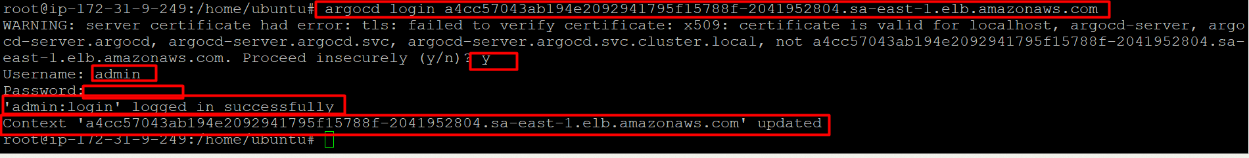

Change the password using the command:

argocd account update-password

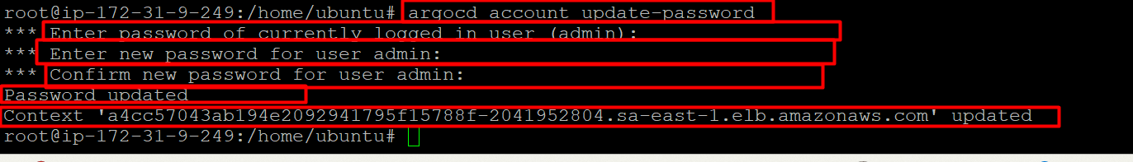

Access argocd on GUI using argocd svc LB external ip add along with port no 80

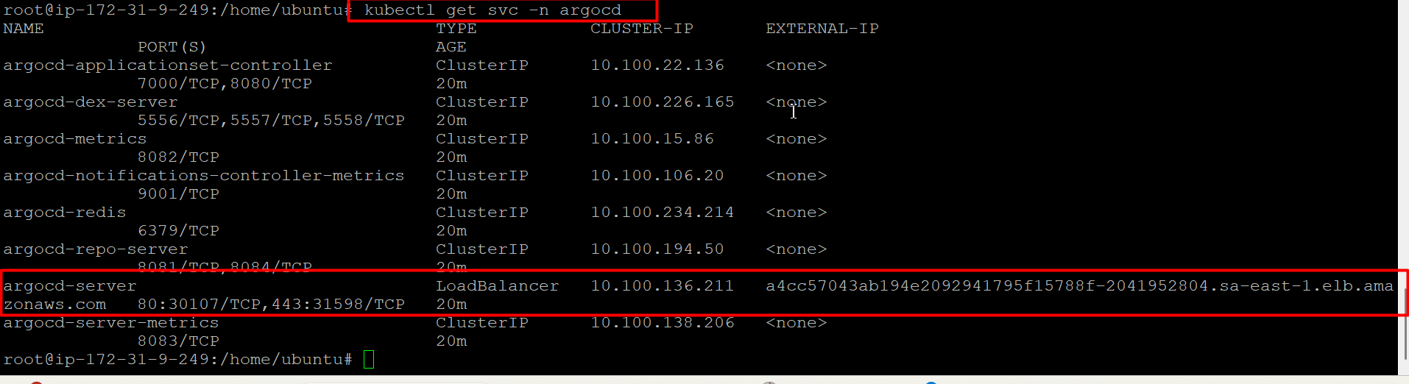

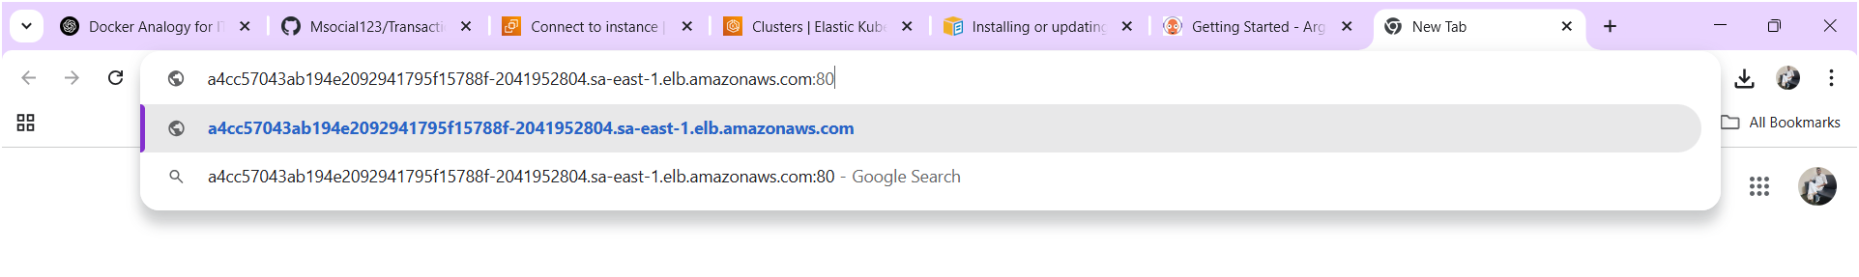

Click on advanced

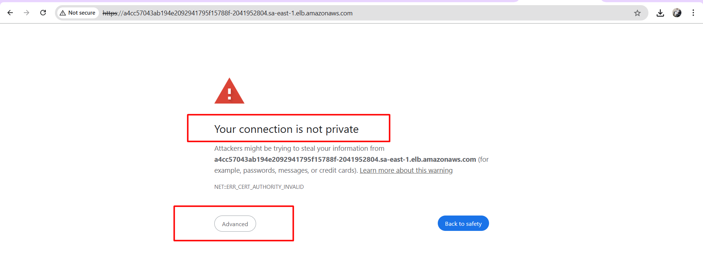

Click on proceed

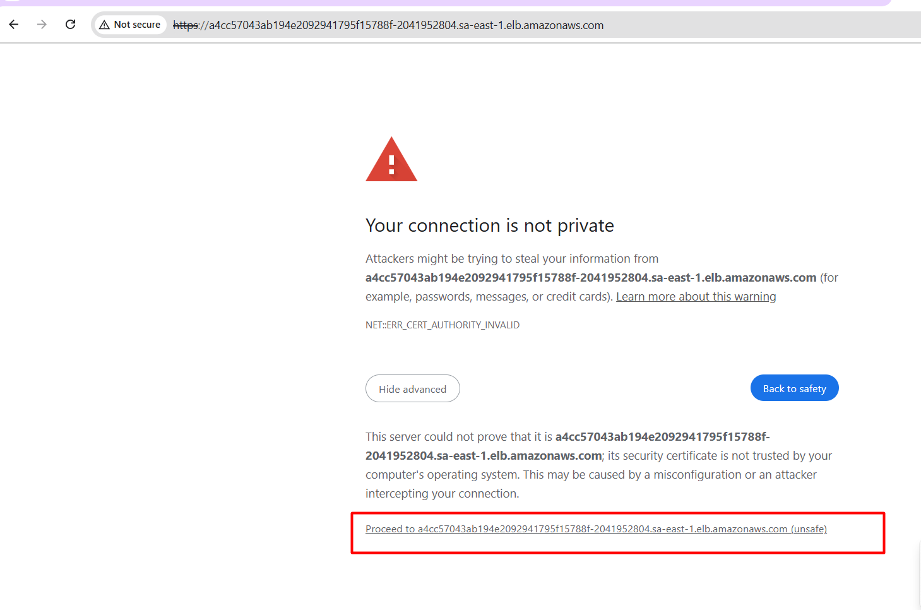

Login to argocd by providing credentials

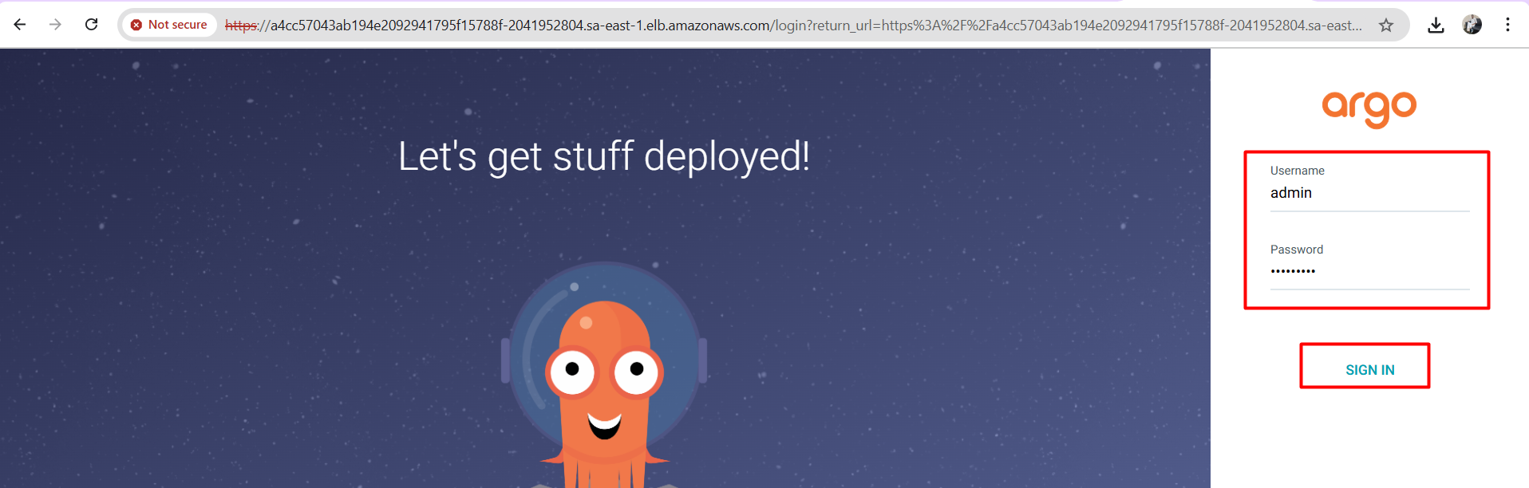

Argocd home page

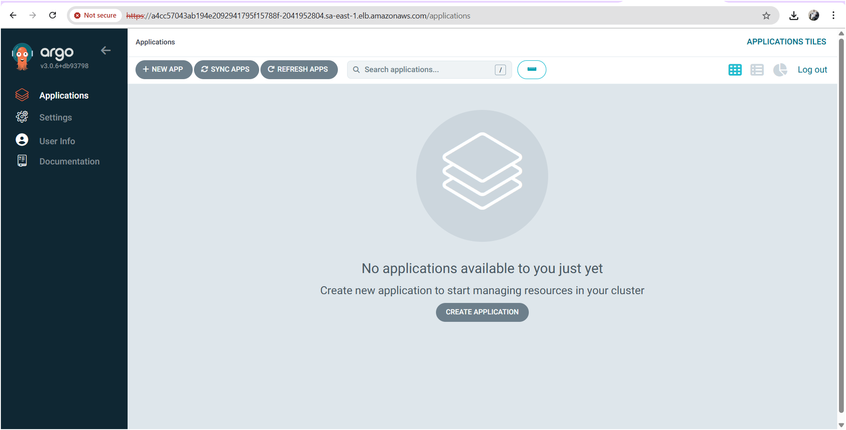

* For deploying app in k8s cluster via argocd we have to create application in argocd UI

Click on create Application

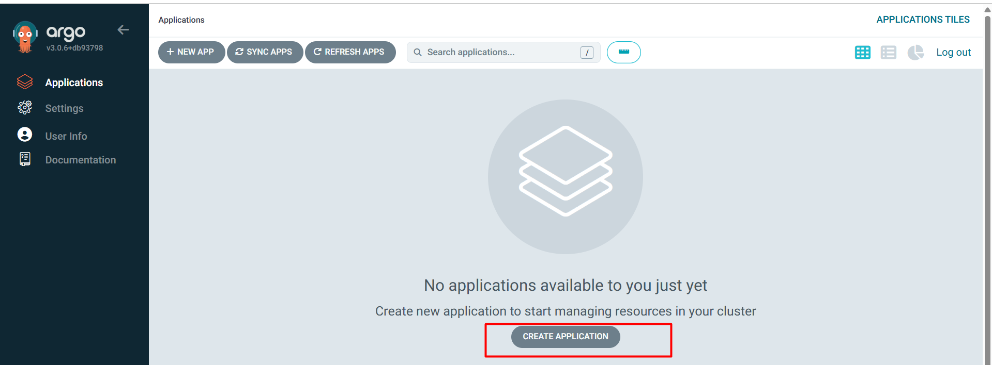

You will get page like this

Fill the following details

In General section

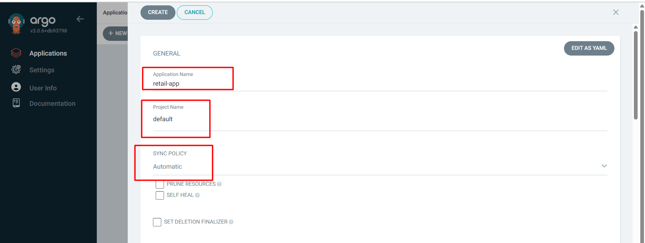

Here it will ask to provide github repo url , branch name and k8s manifest files folder path ( it manifest files are available in root directory provide . (dot) ).

In source section

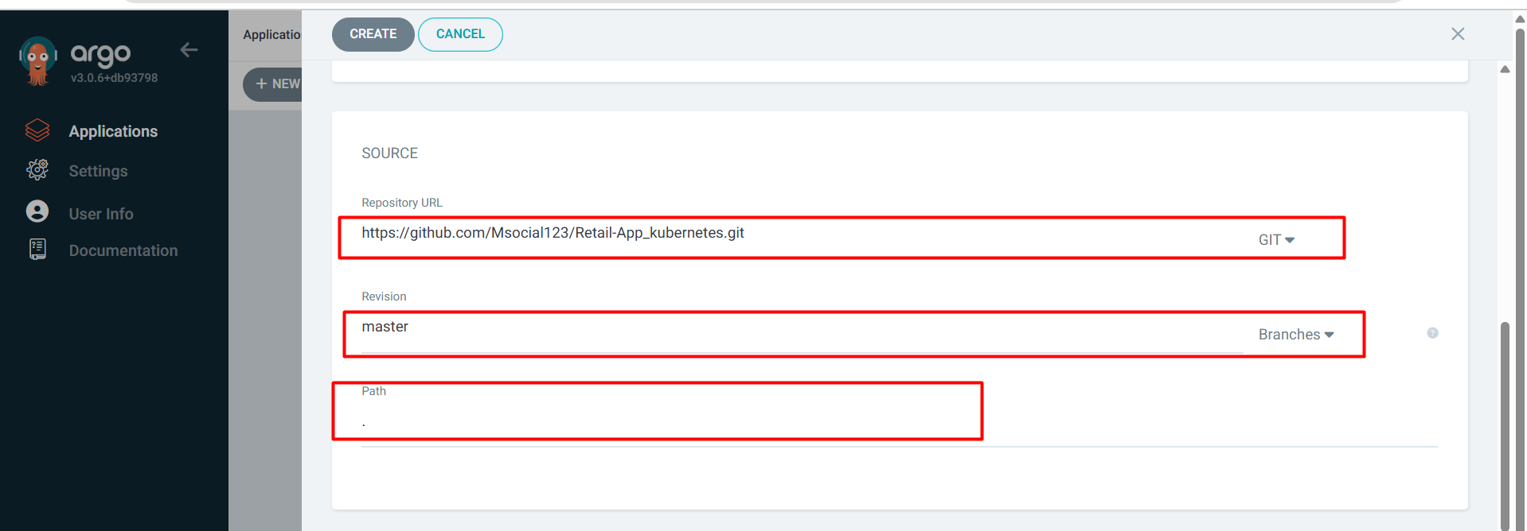

In destination section

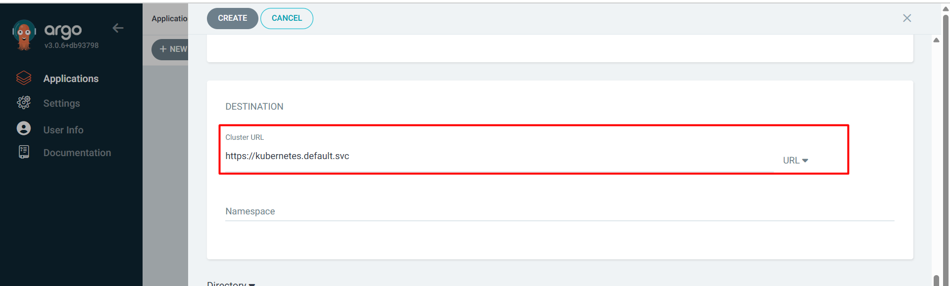

Note : choose namespace as default (if u don’t have own ns)

After filling all details top there is a option named “create” click on create

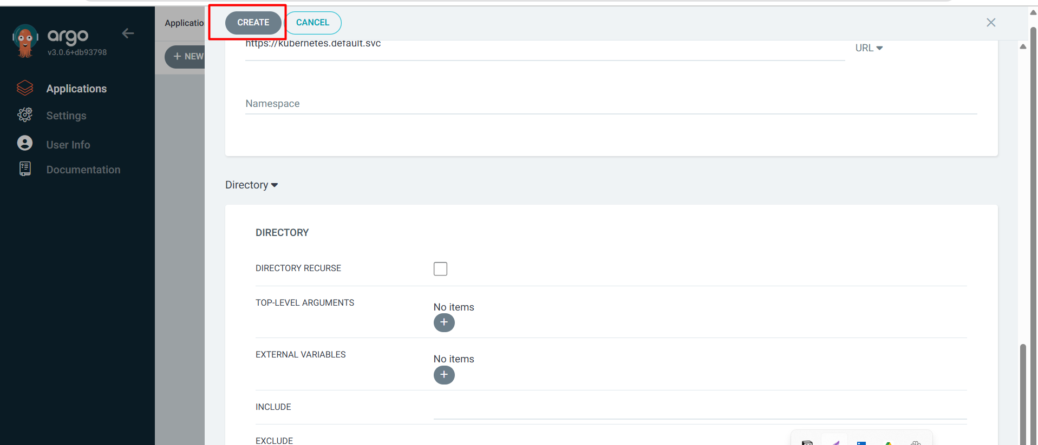

Application created in Argocd

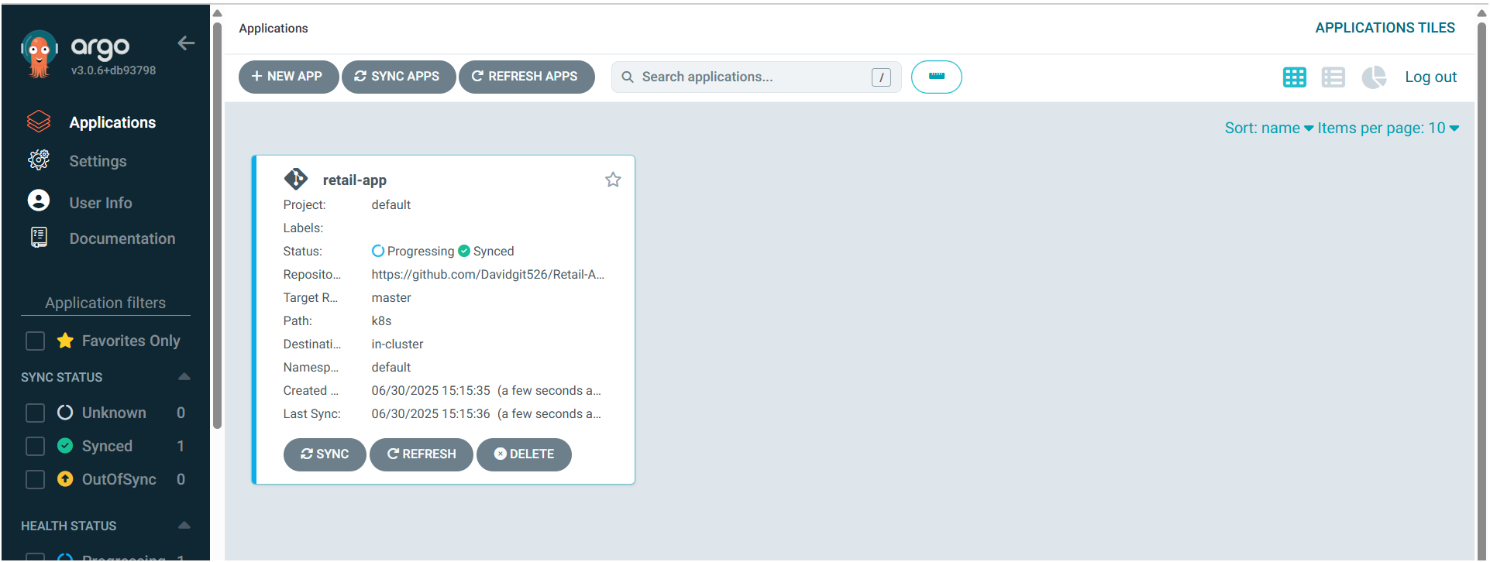

App has been deployed in k8s cluster via argocd

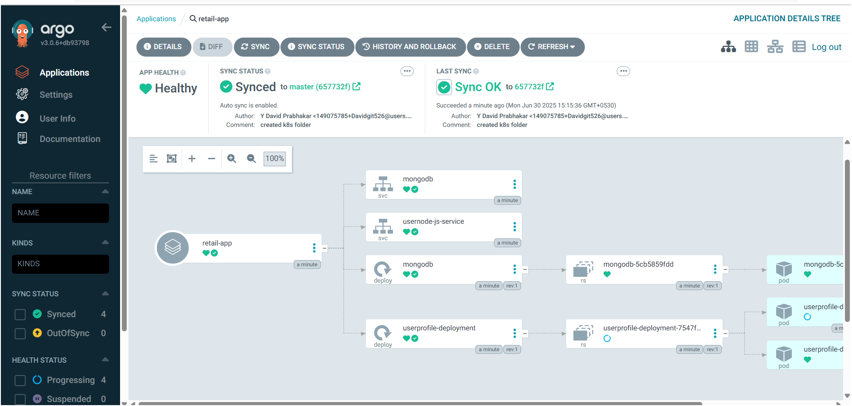

In k8s cluster app resources

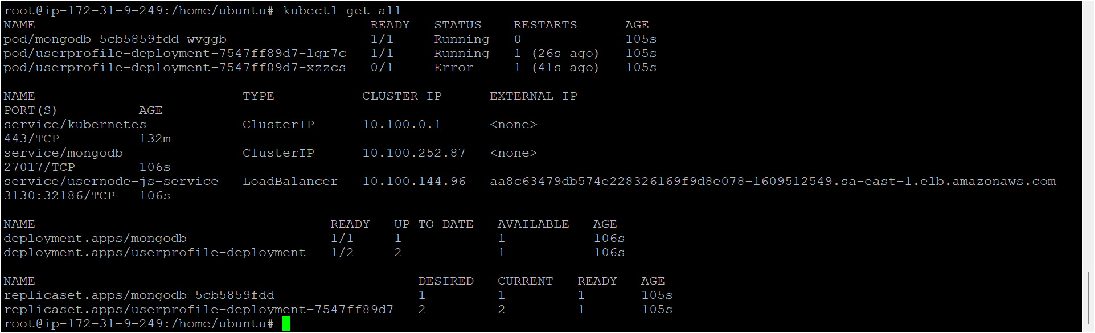

**CrashLoopBackOff Issue in Kubernetes: Documentation & Resolution Steps**

**✅ What is CrashLoopBackOff?**

In Kubernetes, a **CrashLoopBackOff** is an error status for a pod, indicating that a container inside it repeatedly fails to start, crashes, and Kubernetes tries to restart it again and again.

Kubernetes uses an exponential backoff strategy to restart crashing containers, hence the name **CrashLoopBackOff**.

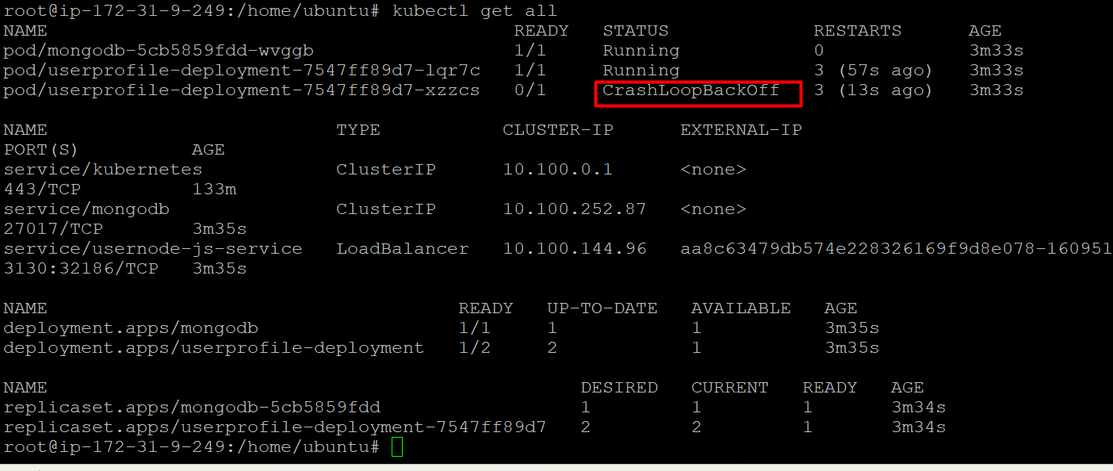

* To resolve this issue we need to cross check container image

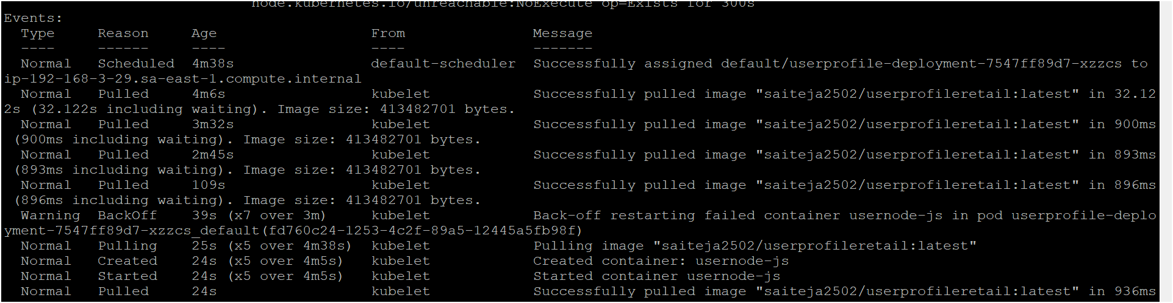

How to implement volumes for this app

PersistentVolume (pv.yaml)

apiVersion: v1

kind: PersistentVolume

metadata:

name: my-pv

spec:

capacity:

storage: 1Gi

accessModes:

- ReadWriteOnce

hostPath:

path: "/mnt/data" # path on the node (for testing)

**PersistentVolumeClaim (pvc.yaml)**

yaml

CopyEdit

apiVersion: v1

kind: PersistentVolumeClaim

metadata:

name: my-pvc

spec:

accessModes:

- ReadWriteOnce

resources:

requests:

storage: 1Gi

kubectl apply -f pv.yaml

kubectl apply -f pvc.yaml

* Am able to access my application

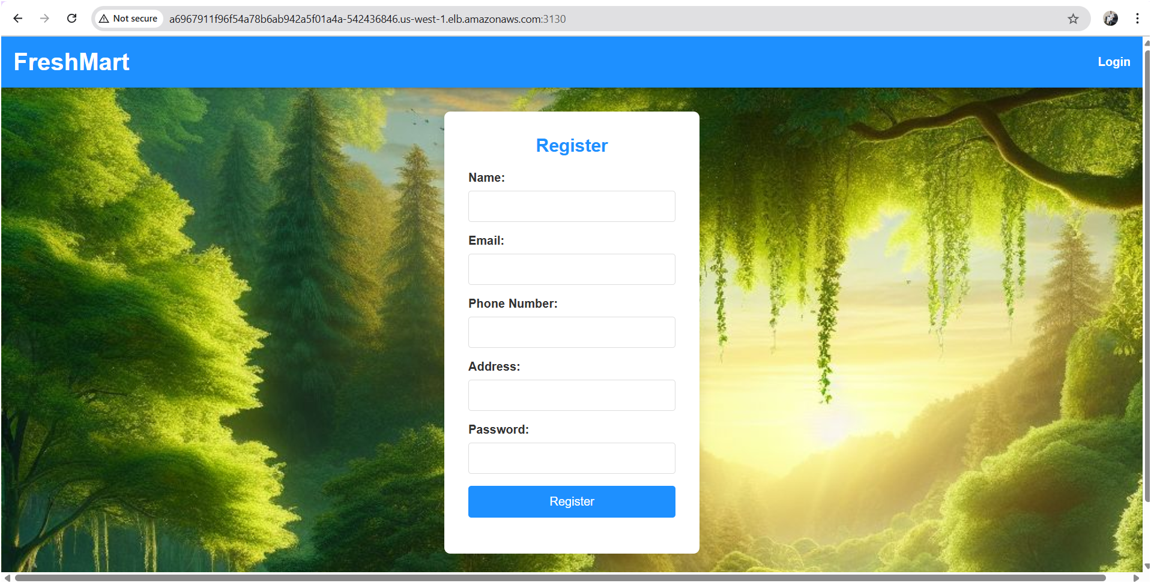

Logged into the app

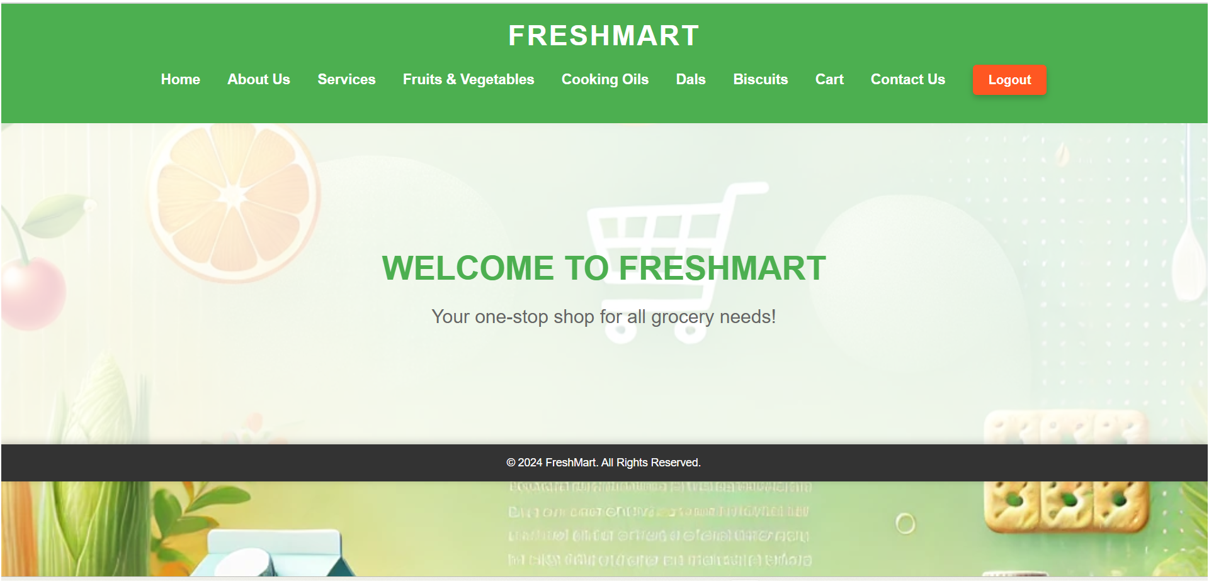

How to see the which is stored in mongodb server

Entre inside the pod

kubectl exec -it mongodb-5cb5859fdd-cnnkw – mongosh

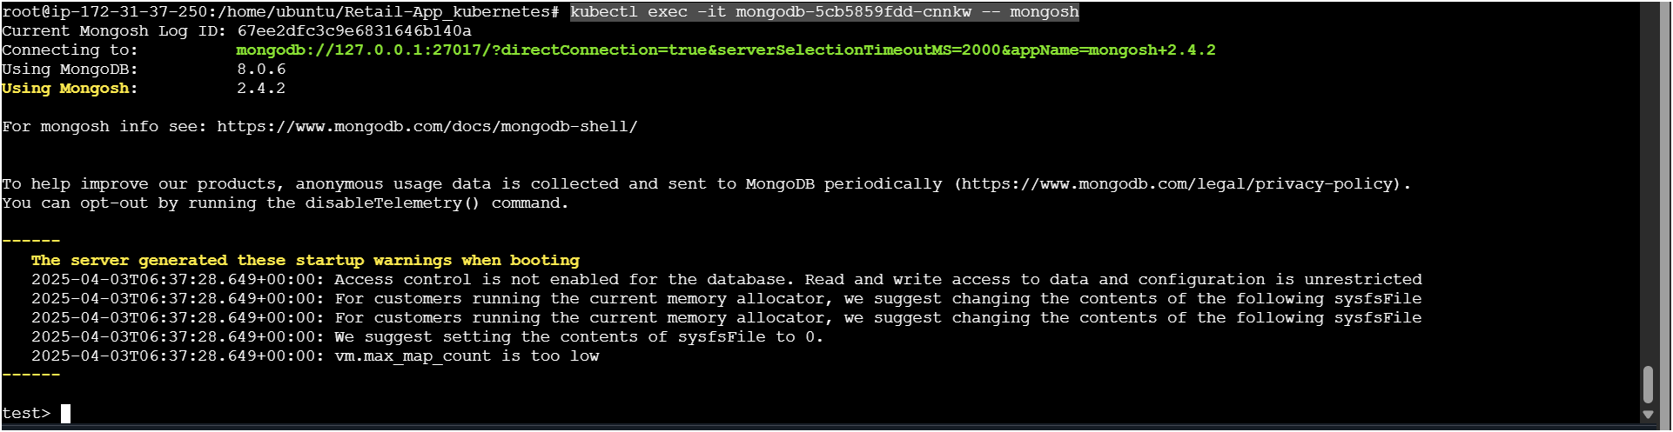

show dbs

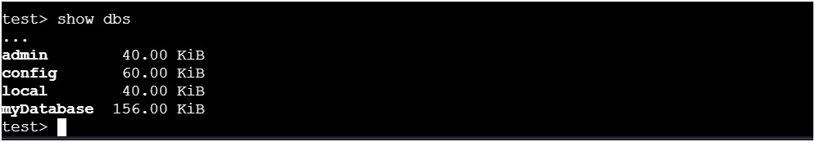

Choose your db and get the data

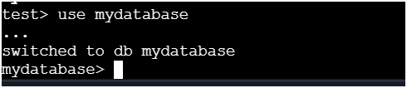

show collections (after executing this command wait few mints)

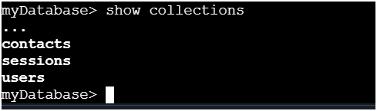

db.users.find().pretty()

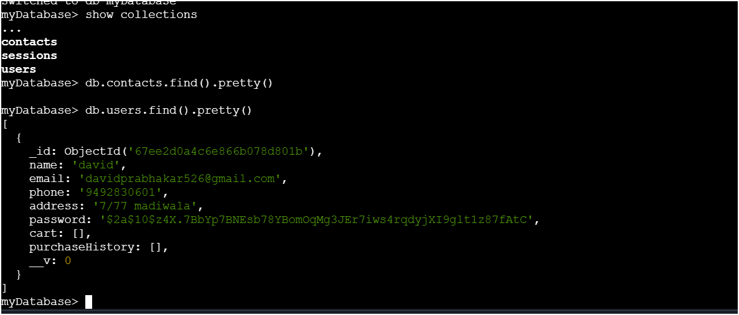

THE END